**Indira College of Engineering and Management Pune**



**Electricity Billing System**

Project Submitted By

**Nainesh Gopalrao Iche - 81107**

Under the Guidance of

**Dr. Darshana Desai Mam**

**(SRS)**

**Software Requirements Specification**

**Version: (1)** **Date: (18/04/2021)**

**TABLE OF CONTENTS**

**1 Introduction**

1.1 Preamble

1.2 Problem Statement

1.3 Proposed Solution

**2 Analysis And System Requirements**

2.1 Existing And Proposed System

2.2 Software & Hardware Requirements

**3 System Design And Modeling**

3.1 Preliminary Design

3.1.1 Schema Diagram

3.1.2 Class Diagram

3.1.3 Sequence Diagram

3.1.4 Use Case Diagram

3.1.5 E-R Diagram

3.1.6 Module Hierarchy Diagram

3.2 Normalization

3.2.1 First Normal Form(1nf)

3.2.2 Second Normal Form(2nf)

3.3.3 Third Normal Form(3nf)

**4 Implementation**

4.1 Implementation Of Operations

4.2 Algorithm Or Pseudocode Of Implementation

**5 Discussion**

5.1 Tables

5.2 Snapshots

**6 Conclusion**

**7 References**

**LIST OF FIGURES**

FIG 3.1.1: Schema diagram of Electricity Billing System

FIG 3.1.2 : Class diagram of Electricity Billing System

FIG 3.1.3 : Object diagram of Electricity Billing System

FIG 3.1.4 : Use Case diagram of Electricity Bill Payment System:

FIG 3.1.5 : ER diagram of Electricity Billing System.

FIG 3.1.6 : Module Hierarchy diagram of Electricity Billing System.

FIG 3.1.7 : Activity diagram of Electricity Billing System.

FIG 5.1.1 : List of All Tables

FIG 5.1.2 : Login Table

FIG 5.1.3 : Customer Table

FIG 5.1.4 : Tax Table

FIG 5.1.5 : Bill Table

FIG 5.1.6 : Meter_Info Table

FIG 5.2.1 : Splash page of Electricity Billing System

FIG 5.2.2 : Login page of Electricity Billing System

FIG 5.2.3 : Sign up page of Electricity Billing System

FIG 5.2.4 : Admin home page

FIG 5.2.5: Admin Home page

FIG 5.2.6: Customer Info page

FIG 5.2.7: Customer Details page

FIG 5.2.8: Calculate Bill page

FIG 5.2.9: Customer Home page

FIG 5.2.10: Update customer details page

FIG 5.2.11: Bill Details page

FIG 5.2.12: Pay Bill page

FIG 5.2.13: Generate Bill page

FIG 5.2.14: Generate Bill page

**INTRODUCTION**

Electricity Billing System is a software-based application.

1. This project aims at serving the department of electricity by computerizing the billing system.
2. It mainly focuses on the calculation of units consumed during the specified time and the money to be charged by the electricity offices.
3. This computerized system will make the overall billing system easy, accessible, comfortable, and effective for consumers.

To design the billing system more service oriented and simple, the following features have been implemented in the project. The application has high speed of performance with accuracy and efficiency.

The software provides facility of data sharing, it does not require any staff as in the conventional system. Once it is installed on the system only the meter readings are to be given by the admin where customer can view all details, it has the provision of security restriction.

The electricity billing software calculates the units consumed by the customer and makes bills, it requires small storage for installation and functioning. There is provision for debugging if any problem is encountered in the system.

The system excludes the need of maintaining paper electricity bill, administrator does not have to keep a manual track of the users, users can pay the amount without visiting the office. Thus, it saves human efforts and resources.

**1.1 Preamble**

I’m, the owners of my project, respect all customers and make them happy with our service.

The main aim of our project is to satisfy customer by saving their time by payment process, maintaining records, and allowing the customer to view his/her records and permitting them to update their details.

The firm handles all the work manually, which is very tedious and mismatched.

The objectives of our project are as follows:

* To keep the information of Customer.
* To keep the information of consuming unit energy of current month.
* To keep the information of consuming unit energy of previous month.
* To calculate the units consumed every month regularly.
* To generate the bills adding penalty and rent.
* To save the time by implementing payment process online.

**1.2 Problem Statement**

The manual system is suffering from a series of drawbacks. Since whole of the bills is to be maintained with hands the process of keeping and maintaining the information is very tedious and lengthy to customer. It is very time consuming and laborious process because, staff need to be visited the customers place every month to give the bills and to receive the payments. For this reason, we have provided features Present system is partially automated (computerized), existing system is quite laborious as one must enter same information at different places.

**1.3 Proposed Solution**

1. This project system excludes the need of maintaining paper electricity bill as all the electricity bill records are managed electronically.
2. Administrator doesn't have to keep a manual track of the users. The system

Automatically calculates fine.

1. Users don't have to visit to the office for bill payment.
2. There is no need of delivery boy for delivery bills to user's place. o Thus, it saves human efforts and resources.

**ANALYSIS AND SYSTEM REQUIREMENT**

**2.1 Existing and Proposed System**

The conventional system of electricity billing is not so effective; one staff must visit each customer’s house to note the meter readings and collect the data. Then, another staff must compute the consumed units and calculate the money to be paid. Again, the bills prepared are to be delivered to customers. Finally, individual customer must go to electricity office to pay their dues.

Hence, the conventional electricity billing system is uneconomical, requires many staffs to do simple jobs and is a lengthy process overall. In order to solve this lengthy process of billing, a web based computerized system is essential. This proposed electricity billing system project overcomes all these drawbacks with the features. It is beneficial to both consumers and the company which provides electricity.

With the new system, there is reduction in the number of staffs to be employed by the company. The working speed and performance of the software is faster with high performance which saves time. Furthermore, there is very little chance of miscalculation and being corrupted by the staffs.

**2.2 Software & Hardware Requirements**

**Hardware Requirements:**

* Hardware Specification: -Processor Intel Pentium V or higher
* Clock Speed: -1.7 GHz or more
* System Bus: -64 bits
* RAM: -4GB
* HDD: -500GB
* Monitor: -LCD Monitor
* Keyboard: -Standard keyboard
* Mouse: -Compatible mouse

**Software Requirements:**

* Operating System: -Windows 10
* Software: - NetBeans IDE 8.2
* Front End: -Java core/swings
* Back End: -My SQL

**SYSTEM DESIGN AND MODELLING**

**3.1 Preliminary Design**

System design is an abstract representation of a system component and their relationship and which describe the aggregated functionally and performance of the system. It is also the plan or blueprint for how to obtain answer to the question being asked. The design specifies various type of approach.

Database design is one of the most important factors to keep in mind if you are concerned with application performance management. By designing your database to be efficient in each call it makes and to effectively create rows of data in the database, you can reduce the amount of CPU needed by the server to complete your request, thereby ensuring a faster application.

**3.1.1 Schema Diagram**

Database schema is described as database connections and constraints. It contains attributes. Every database has a state instances represent current set of databases with values. There are different types of keys in a database schema.

A primary key is a table column that can be used to uniquely identify every row of the table. Any column that has this property, these columns are called candidate key. A composite primary key is a primary key consisting of more than one column. A foreign is a column or combination of columns that contains values that are found in the primary key of some table.

All the attributes of each table are interconnected by foreign key which is primary key in another column and composite key. Primary key cannot be null. The fact that many foreign key values repeat simply reflects the fact that its one-to-many relationship. In one-to-many relationship, the primary key has the one value and foreign key has many values.

Figure 3.1.2 is a Schema diagram of Electricity Billing System which has six tables i.e., login, customer, tax, rent, bill, and meter_info where each table contain attributes some with primary key. In the login table there are 6 attributes "meter_no”, "username”, “password”, "user”, "question”, "answer”. The customer table has 7 attributes "name”, "meter_no"(primary key), "address”, "city”, "state”, “email”, "phone”. The rent table has 3 attributes "cost_per_unit"(primary key), " meter_rent”, "service_charge". The tax table has 3 attributes " service_tax”, "swacch_bharat_cess”, "gst”.

The bill table has 5 attributes "meter_no"(foreign key that references the primary key of the customer table meter_no), "month”, "units”,"total_bill”, "status”. The meter_info table has 6 attributes "meter_no"(foreign key that references the primary key of the customer table meter_no), "meter_location”, "meter_type”, "phase_code”, " bill_type”, "days ".

**Schema Diagram :-**

**Login**

|  |  |  |  |
| --- | --- | --- | --- |
| meter_no | Username | password | user |

**Customer :-**

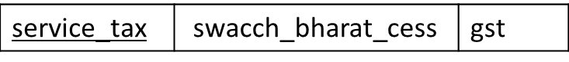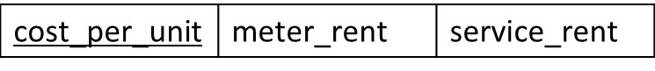

**Meter Info :**

**Bill :**

**Tax :**

**Rent :**

**FIG 3.1.1: Schema diagram of Electricity Billing System**

**3.1.2 Class Diagram :-**

Electricity Bill Payment System Class Diagram describes the structure of a Electricity Bill Payment System classes, their attributes operations for met ods), and the relationships among objects. The main classes of the Electricity Bill Payment System are Bitls, Customers, Connections. Une Readings Consuptions.

**Classes of Electricity Bill Payment System Class Diagram:**

* Customers Class : Manage all the operations of Customers
* Admin Class: Manage all the operations of Admin
* Meter_Info: Customer Meter details
* Payment: Details of customer payments
* Tax: Contains taxes send by Gov.

**Classes and their attributes of Electricity Bill Payment System Class Diagram:**

* Customer Attributes : bill id, bill customer_id, bill number, bill type, bill receipt, bill description
* Admin Attributes : customer_id, customer name, customer mobile customer_email customer_usemame, customer password customer address
* Meter Attributes : connection_id connection_name connection_type connection description
* Payment Attributes : unit_id, unit name, unit_type, unit description
* Tax Attributes : reading id reading name, reading type, reading_description

**Classes and their methods of Electricity Bill Payment System Class Diagram:**

* Bills Methods : addBills(), editBills(), deleteBills(), updateBills(), saveBills(), searchBits()
* Customers Methods : addCustomers(), editCustomers(), delete Customers(), updateCustomers(), saveCustomers(), searchCustomers()
* Connections Methods : addConnections(), editConnections(), deleteConnections(), updateConnections(), saveConnections), search Connections()
* Units Methods : addUnits(), editUnits(), deleteUnits), updateUnits(), saveUnits(), searchUnits()
* Readings Methods : addReadings(), editReadings(), deleteReadings(), update Readings(), saveReadings(), searchReadings()
* Consuptions Methods : addConsuptions(), editConsuptions(), deleteConsuptions(), updateConsuptions(), saveConsuptions), search Consuptions()

**Class Diagram :-**

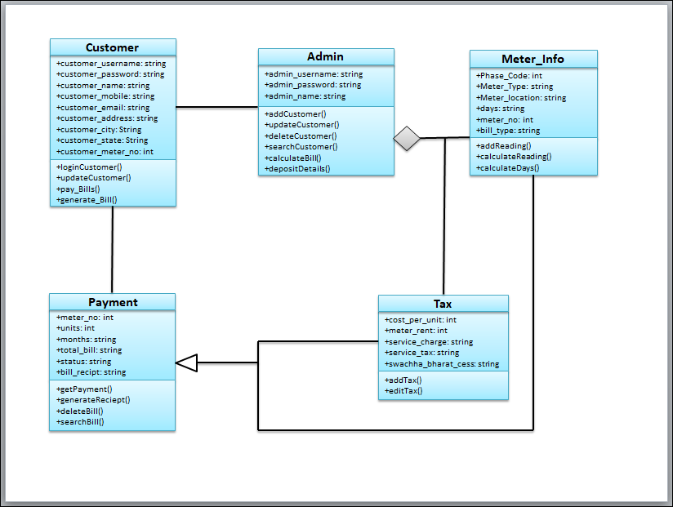

**FIG 3.1.2 : Class diagram of Electricity Billing System**

**3.1.3 Sequence Diagram :-**

**Sequence Diagram :-**

This is the UML sequence diagram of Electricity Bill Payment System which shows the interaction between the objects of Customers. Readings, Consuptions Units Bills. The instance of class objects involved in this UML Sequence Diagram of Electricity Bill Payment System are as follows:

* EBS
* Customer Management
* Bill Pay
* Unit Management
* Verification
* Database

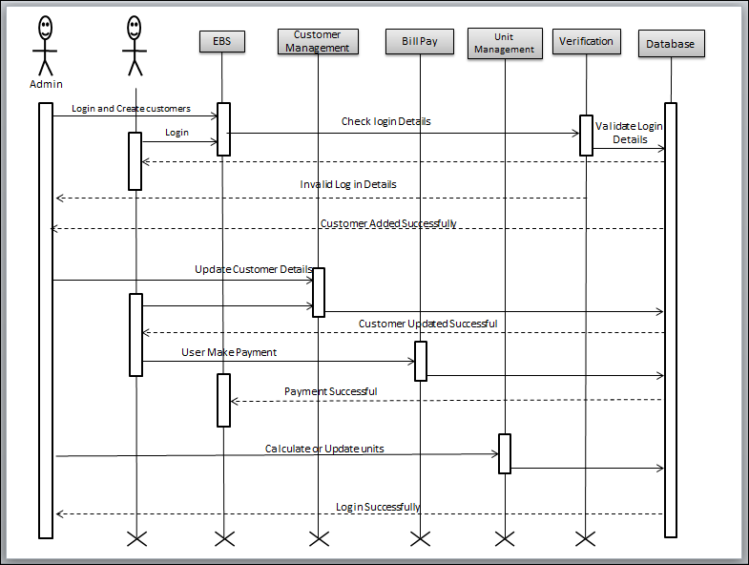

**FIG 3.1.3 : Sequence diagram of Electricity Billing System**

**3.1.4 USE Case Diagram :-**

This Use Case Diagram is a graphic depiction of the interactions among the elements of Electricity Bill Payment Systems it represents the methodology used in system analysis to identity clarity, and organize system requirements of Electricity Bill Payment System. The main actors of Electricity Pay ment System in this Use Case Diagram are Super Admin System User Customer Cashier, who perform the different type of use cases such as Mar age Bills, Manage Customers. Manage Connections Manage Units, Manage Readings, Manage Consuptions, Manage Users and Full Electricity Payment System Operations. Major elements of the UML use case diagram of Electricity Bill Payment System are shown on the picture below

* Customer Entity Use cases of Customer are Check Bills, Check Bill Summary, Make Payment Check Payment History.
* Admin Entity : Use cases of Admin are Manage Bills, Manage Customers, Manage Connections, Manage Units, Search Customer. Manage Consuptions Manage Users and Full Electricity Bill Payment System Operations

**Use Case Diagram :-**

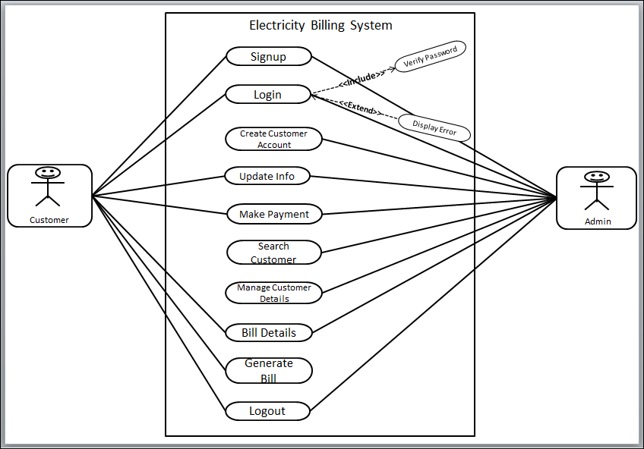

**FIG 3.1.4 : Use Case diagram of Electricity Bill Payment System:**

**3.1.5 Entity-Relationship Diagram :-**

An entity relationship diagram (ERD) shows the relationships of entity sets stored in a database. An entity in this context is an object, a component of data. An entity set is a collection of similar entities. These entities can have attributes that define its properties.

There are two reasons to create a database diagram. You’re either designing a new schema or you need to document our existing structure.

If you have an existing database you need to document, you create a database diagram using data directly from your database. You can export your data base structure as a CSV file (there are some scripts on how to do this here), then have a program generate the ERD automatically.

An ER diagram is a means of visualizing how the information a system produces is related. There are five main components of an ERD:

* Entities, which are represented by rectangles. An entity is an object or concept about which you want to store information.
* A weak entity is an entity that must defined by a foreign key relationship with another entity as it cannot be uniquely identified by its own attributes alone.
* Actions, which are represented by diamond shapes, show how two entities share information in the database.
* In some cases, entities can be self-linked. For example, employees can supervise other employees.
* Attributes, which are represented by ovals. A key attribute is the unique, distinguishing characteristic of the entity.
* A multivalued attribute can have more than one value. For example, an employee entity can have multiple skill values.
* A derived attribute is based on another attribute. For example, an employee's monthly salary is based on the employee's annual salary.
* Connecting lines, solid lines that connect attributes to show the relationships of entities in the diagram.
* Cardinality specifies how many instances of an entity relate to one instance of another entity. Ordinality is also closely linked to cardinality.

**E-R Diagram :-**

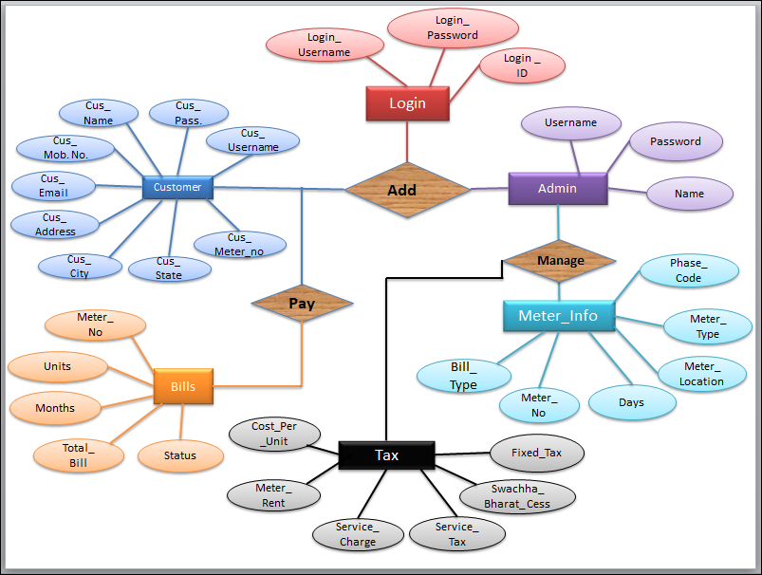

**FIG 3.1.5 : ER diagram of Electricity Billing System.**

It has 5 entities namely login, Customer, Admin, Bills, Meter_Info and Tax. The entities have attributes which are primary and foreign and attributes.

**3.1.6 Module Hierarchy Diagram :-**

**Module Hierarchy Diagram :-**

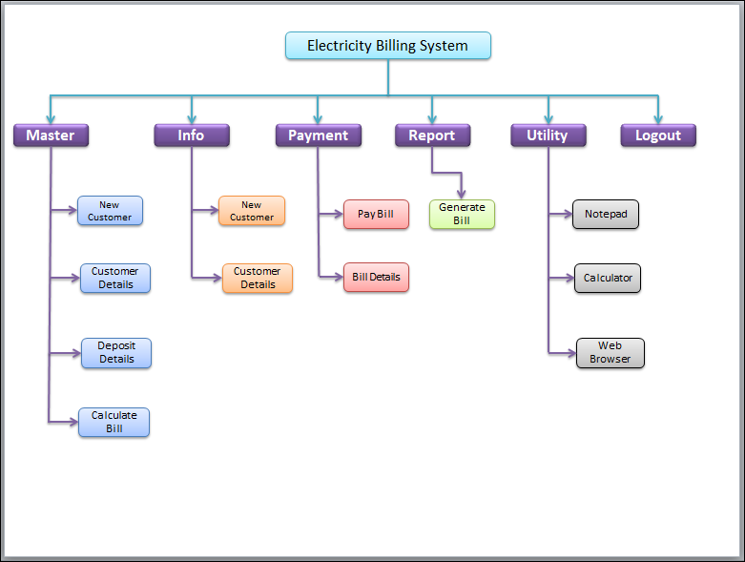

**FIG 3.1.6 : Module Hierarchy diagram of Electricity Billing System.**

**3.1.7 Activity Diagram:**

This is the Activity UML diagram of Electricity Bill Payment System which shows the flows between the activity of Consuptions, Customers. Read ings, Balls, Units. The main activity involved in this UML Activity Diagram of Electricity Bill Payment System are as follows

Features Of The Activity UML Diagram Of Electricity Bill Payment System

• Admin User can search Consuptions, view description of a selected Consuptions, add Consuptions, update Consuptions and delete Consuptions Its shows the activity flow of editing, adding and updating of Customers

User will be able to search and generate report of Readings, Bills, Units All objects such as (Consuptions, Customers, Units) are interlinked

Its shows the full description and flow of Consuptions. Dils. Units: Readings, Customers

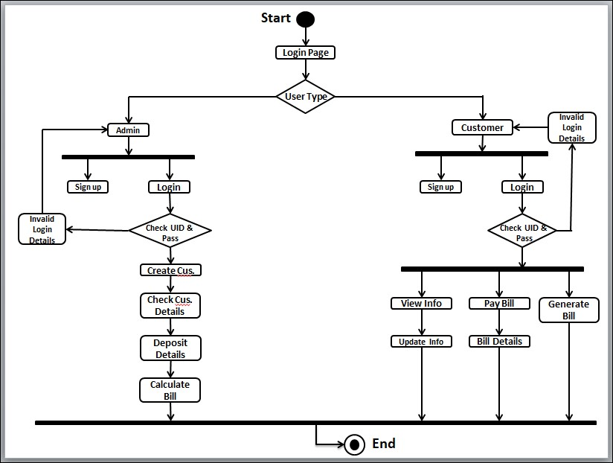

**FIG 3.1.7 : Activity diagram of Electricity Billing System.**

**3.2 Normalization**

Normalization is a process of organizing the data in database to avoid data redundancy, insertion anomaly, update anomaly & deletion anomaly.

Let’s discuss about anomalies first then we will discuss normal forms with examples. Anomalies in DBMS There are three types of anomalies that occur when the database is not normalized. These are –Insertion, update and deletion anomaly.

**3.2.1 First normal form(1NF)**

As per the rule of first normal form,

* All rows must be unique (no duplicate rows).
* Each cell must only contain a single value (not a list).
* Each value should be non-divisible (can't be split down further).

Customer

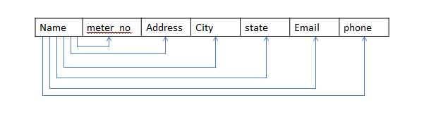

**3.2.2 Second normal form(2NF)**

As per the rule of second normal form,

* Database must be in First Normal Form.
* Non partial dependency-All non-prime attributes should be fully functionally dependent on the candidate key.

**3.2.3** **Third normal form(3NF)**

As per the rule of third normal form,

* Database must be in First and Second Normal Form.
* Nontransitive dependency-All fields must only be determinable by the primary/composite key, not by other keys.

**IMPLIMENTATION**

**4.1 Implementation of operations**

* **Adding Customer:** Here admin can add new customer to the customer list who started using electricity bill system.
* **Searching Deposit Details:** Here admin can search according to meter number and month to view deposit details.
* **Viewing Details**: Here admin and user can view customer details and about details.
* **Adding Tax:** Here admin can add tax details.
* **Updating Customer:** Here customer can update his/her details by using meter_no of the customer.
* **Delete Customer:** Here admin can delete details based on meter number.

**4.2 Algorithm or pseudocode of implementation**

**Explanation of Algorithm or pseudocode of system:**

* Start system
* Enter login name and password
* On clicking the login button
* Connect to database
* Query database to know whether user credentials are correct
* If not, deny access and return login page with an error message
* If correct, check if credentials for administrator
* If yes, allow login
* Set admin session, re-direct administrator to admin login page
* If no, allow login set user session
* Re-direct user to user home page

**Algorithm or pseudocode of admin:**

**Login:**

* This program will allow the admin to enter the username and password.
* If the entered credentials are correct, then the login will be successful otherwise need to be signup.
* If admin forgets password, it can be retrieved by giving username and answer for security question.
* After successful login the admin will be redirected to admin portal page where he/she can do following activities.

**New Customer :**

* This program will allow the admin to enter the customer details and automatically generates unique meter number.
* If customer name, address, city, state, email and phone number is entered, insert the values into customer
  + else print error while next=true
  + enter the meter_info details else print meter_info error
  + Submit the details of customer that has been entered by clicking onto next button.
* If we need to cancel the particulars that has been entered click onto cancel option.
* If we need to submit the particulars that has been entered click onto submit option.

**Customer Details:**

* This program will allow the admin to view customer details.
* If we need to print the particulars that has been viewed click onto print option.

**About:**

* This program will allow the admin to view details of the project in short.
* If we need to exit the particulars that has been viewed click onto exit option.

**Algorithm or pseudocode of Customer:**

**Login:**

* This program will allow the customer to enter the username and password. If the entered credentials are correct, then the login will be successful otherwise need to be signup with the meter_no which is given by admin.
* If customer forgets password, it can be retrieved by giving username and answer for security question. After successful login the customer will be redirected to customer portal page where he/she can do following activities.

**UpdateInfo1:**

* This program will allow the customer to update the customer details. If customer address, city, state, email and phone number is updated,

update the values into customer else print error

update the details of customer that has been updated by clicking onto update button.

* If we need to cancel the particulars that has been updated, click onto back option.

**View Info:**

* This program will allow the customer to view his/her own details.
* If we need to go back from the particulars that has been viewed click onto back option.

**Pay Bill:**

* This program will allow the customer to view bill details and redirects to pay
* the bill where status will be updated.
* If we need to cancel the particulars that has been viewed click onto back option.
* If we need to pay the bill amount that has been viewed click onto pay option.

**Calculate Bill:**

* This program will allow the admin to calculate total_bill when units consumed are inserted where meter_no and month is selected.

insert the values into bill else print error

Submit the details of tax that has been entered by clicking onto submit button.

* If we need to cancel the particulars that has been entered click onto cancel option.

**Generate Bill:**

* This program will allow the customer to generate bill when meter_no and month is selected.
* Generate the details by clicking on generatebill button.

**DISCUSSION**

**5.1 TABLES:**

The given below table is a snapshot of backend view of the localhost and the structures of the tables present in Electricity Billing System. The tables present are login, customer, tax, bill, meter_info.

* The login is used to store the details of login’s admin and customer with meter_no.
* The customer is used to store details of customer.
* The bill is used to store details of bill of meter.
* The meter_info is used to store information of meter placed.
* The Tax is used to store the Extra Charges given by the Gov.

**5.1.1 List of All Tables**

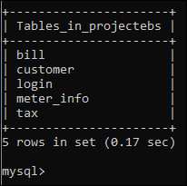

**FIG 5.1.1 : List of All Tables**

**5.1.2 Login Table:**

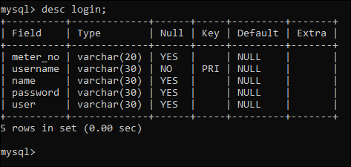

**FIG 5.1.2 : Login Table**

**5.1.3 Customer Table:**

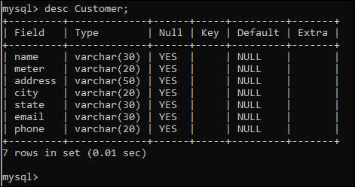

**FIG 5.1.3 : Customer Table**

**5.1.4 Tax Table:**

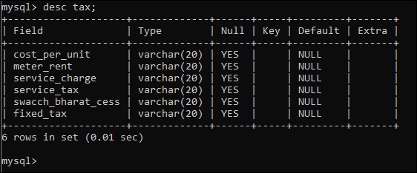

**FIG 5.1.4 : Tax Table**

**5.1.5 Bill Table:**

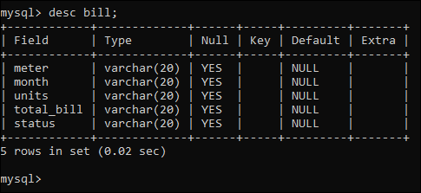

**FIG 5.1.5 : Bill Table**

**5.1.6 Meter_Info Table:**

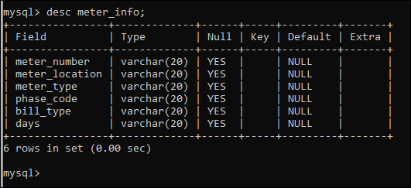

**FIG 5.1.6 : Meter_Info Table**

**5.2 SNAPSHOTS:**

**Splash page :-**

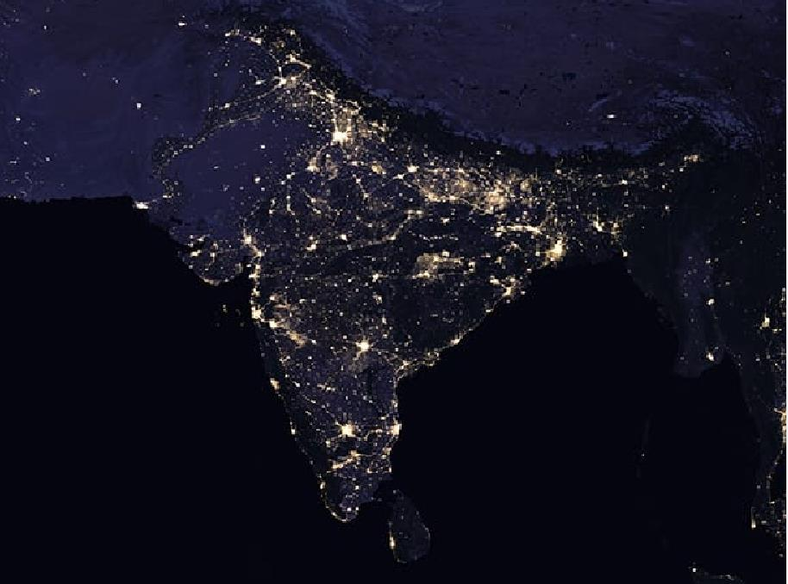

**FIG 5.2.1 : Splash page of Electricity Billing System**

**Login page:**

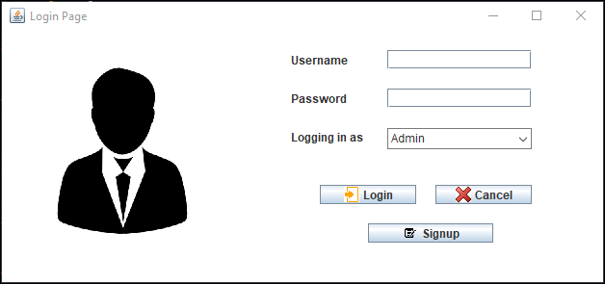

**FIG 5.2.2 : Login page of Electricity Billing System**

**Sign Up Page:**

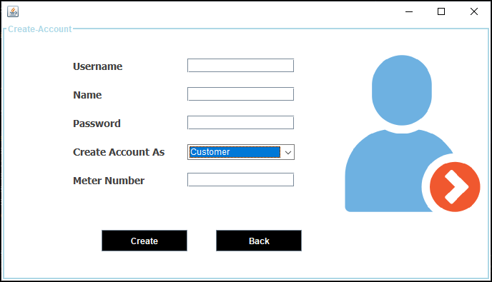

**FIG 5.2.3 : Sign up page of Electricity Billing System**

**5.2.4 Admin Home page:**

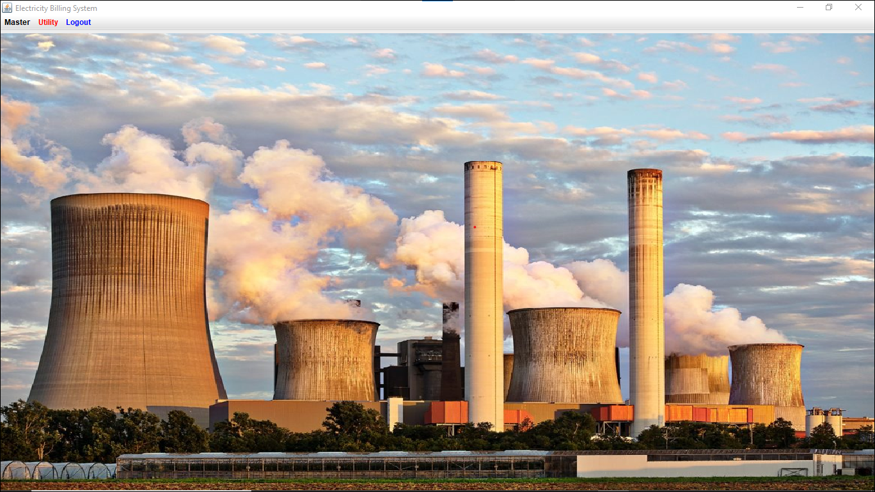

**FIG 5.2.4: Admin Home page**

**New customer page:**

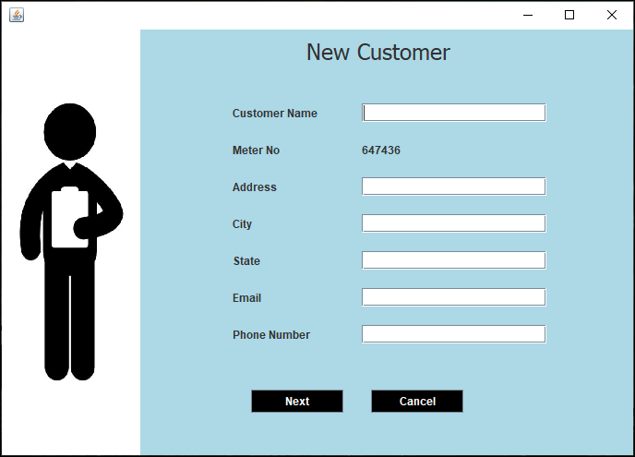

**FIG 5.2.5: Admin Home page**

**Customer Info page:**

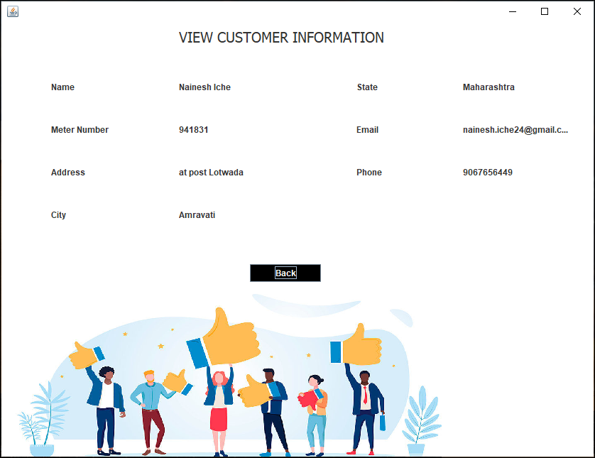

**FIG 5.2.6: Customer Info page**

**Customer Details page:**

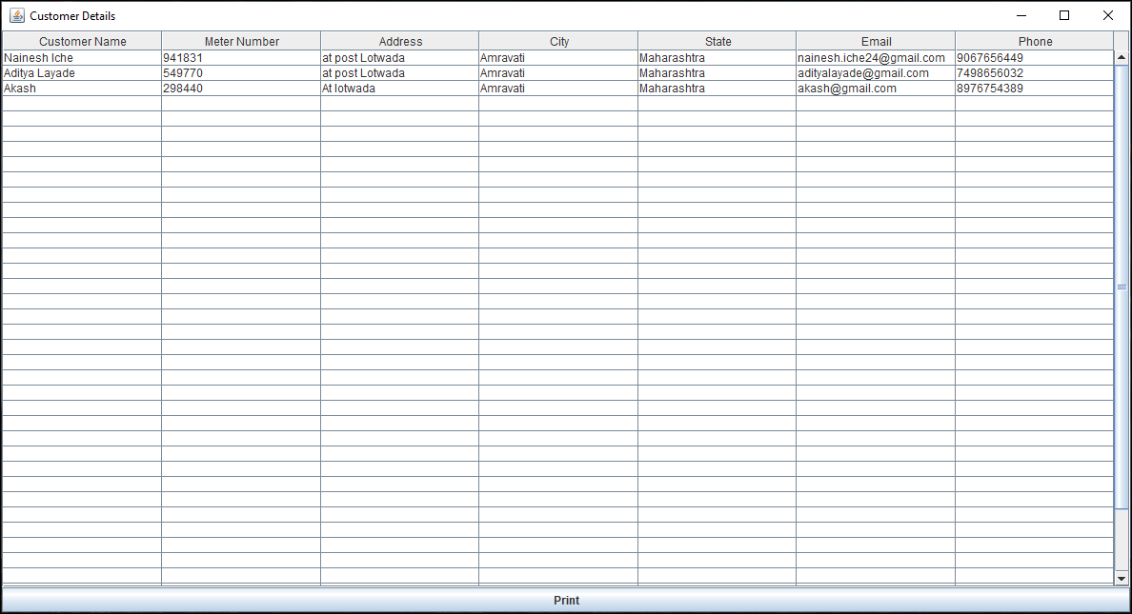

**FIG 5.2.7: Customer Details page**

**Calculate Bill page:**

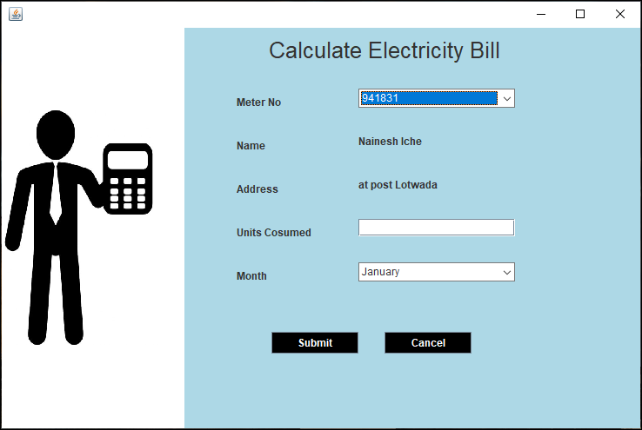

**FIG 5.2.8: Calculate Bill page**

**Customer Home page:**

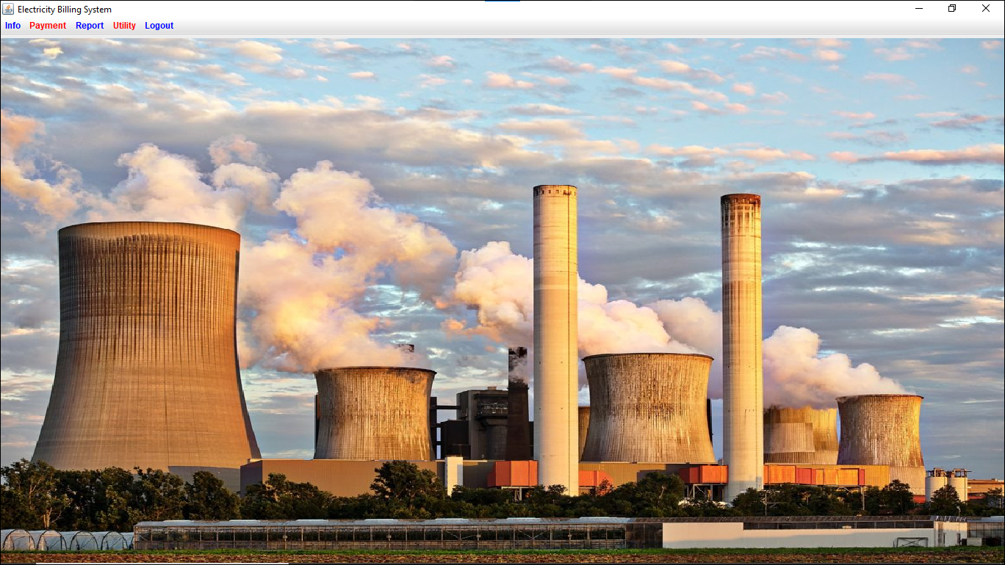

**FIG 5.2.9: Customer Home page**

**Update customer details page:**

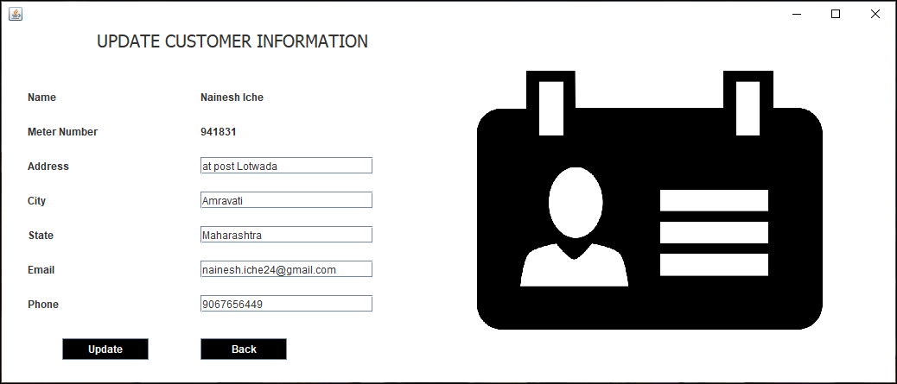

**FIG 5.2.10: Update customer details page**

**Bill Details page:**

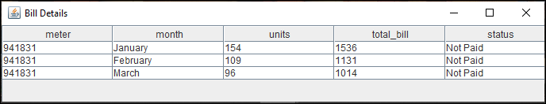

**FIG 5.2.11: Bill Details page**

**Pay Bill page:**

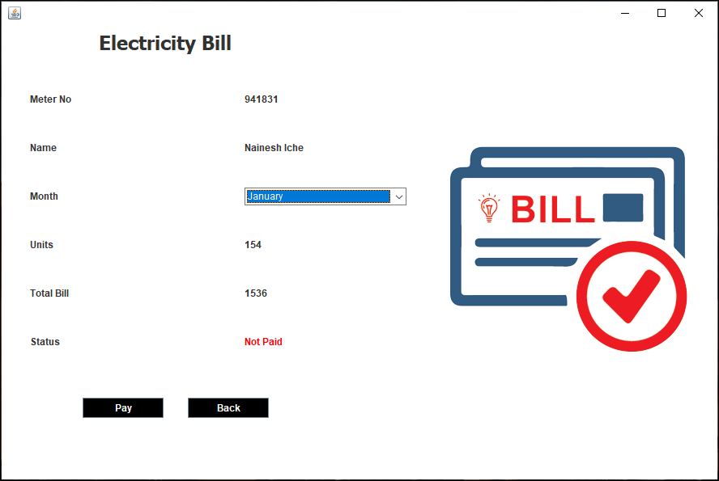

**FIG 5.2.12: Pay Bill page**

**Generate Bill page:**

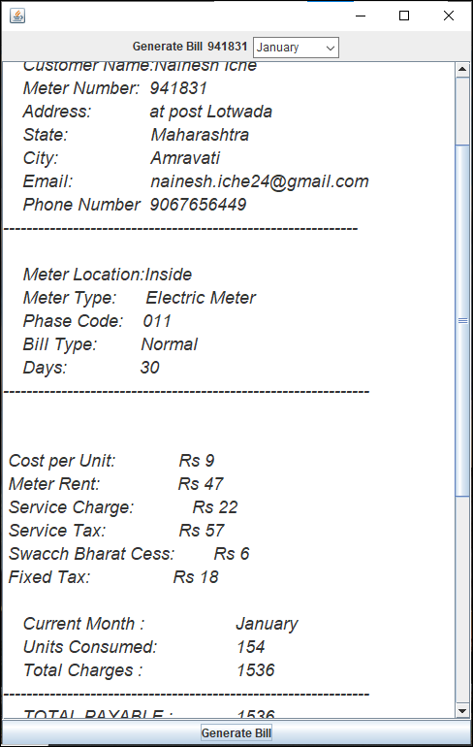

**FIG 5.2.13: Generate Bill page**

**Deposit Details page:**

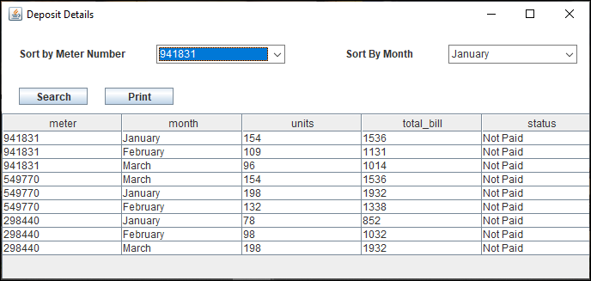

**FIG 5.2.14: Generate Bill page**

**CONCLUSION**

After all the hard work is done for electricity bill management system is here. It is a software which helps the user to work with the billing cycles, paying bills, managing different DETAILS under which are working etc.

This software reduces the amount of manual data entry and gives greater efficiency. The User Interface of it is very friendly and can be easily used by anyone.

It also decreases the amount of time taken to write details and other modules.

**REFERENCES**

**Book References :-**

Database Management Systems 3rd Edition by Raghu Ramakrishnan (TEXTBOOK).

**Websites:-**

* <http://www.github.com>
* [www.stackoverflow.com](http://www.stackoverflow.com/)
* [www.google.com](http://www.google.com/)
* <http://www.javatpoint.com/>
* https://www.w3schools.com/